

**Mauldin Recognized for Environmental Stewardship**

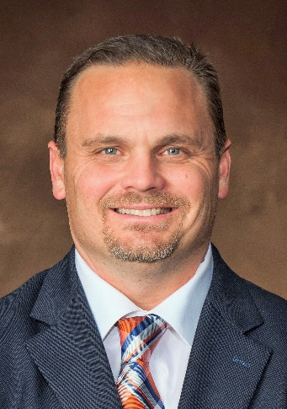

Scott Mauldin, CGCS of Powhatan and The Foundry Golf Club has been recognized by the VGCSA as winner of the 2020 VGCSA Environmental Stewardship Award. The award is presented “in recognition of distinguished and meritorious service in the environmental stewardship of Virginia golf courses, and in grateful appreciation for unselfishly promoting the profession of golf course management, which led to the advancement of the association.”

Mauldin’s first introduction to golf came growing up in Charlotte, NC, when his grandfather would take him out to the golf course. Like many high school students, he had no idea what college he wanted to attend. Then he heard that NC State had started a turf program, and that was a way to work on a golf course. Prior to college, his first golf job was at a municipal course, Charles T. Myers in Charlotte – he earned tickets to play golf. This allowed him to see behind scenes before entering State.

His first job in turf was as a summer intern at Myers Park Country Club during their renovation around 1991. There he worked on spraying and irrigation, then it was back to school. After graduation, his first job was as a spray tech at Carmel Country Club. Then the City of Concord was building a course, Rocky River Golf Club. He learned a lot working with Peter DeJak followed by Bland Cooper (now a PGA Tour agronomist) – he was there 6-7 years.

His next opportunity was at Jacksonville Country Club on the NC coast. He continued to enhance the property for 7 years, then he was ready for a move. PGA member Jason Baile of Kinloch helped recruit him to The Foundry in 2007. The Foundry was doing a complete renovation, including irrigation. During construction, he thought of getting the Audubon Cooperative Sanctuary designation, which was difficult. It was 2010 when they started planning for Audubon and it took a year to get it. It involves a comprehensive course assessment in various disciplines. The process allowed reduced chemicals, reduced water and improving water management overall. They grew native areas and limited the footprint of mowers. They have been recertified three times since. His philosophy is to keep the course natural – very natural and flowing.

Wildlife abounds at The Foundry. You will see heron, bears, coyotes, and birds (bluebirds, finch, hawks, and bald eagles), deer, turkey and ducks. There are plenty of foxes, including a family that tried to make a den in a putting green.

Mauldin manages buffer zones on Fine Creek and other streams and ponds on the property. They just got a new Rain Bird irrigation system, which allows them to manage each individual head. This saves water, it’s the wave of future, with more precise controls. It was designed by Paul Roche, with all controls on your cell phone. Mauldin also uses various moisture meters for managing water throughout the property. Another innovation is buried soil sensors by Spiio, Inc., which sends data to your phone.

When asked about environmental stewardship by superintendents, he said, “We do it every day, so it’s geared into our minds. For instance, draining water to a flat plain instead of diverting it to a creek or spot spraying to reduce the use of chemicals. It’s what we do!”

Mauldin feels lucky to work for a club president who is not a micro-manager, Billy Stinson. The club strives for “understated elegance” according to Mike Barr, one of the founders of the club with 310 members.

“To sum it up,” he said, “every year I strive to keep balance with family and work, stay educated, and to keep having fun and stay on top.”

His family includes wife Tina, his High School sweetheart and daughters Madison (18) who is at East Carolina University, and Sam (16), who attends Monacan HS. And you can’t forget Cooper, the bulldog.